The Fermoy Meals on Wheels service has been in operation in our community for the past 25 years and it continues to go from strength to strength.

The service provides hot nutritional meals to older people, people recovering from illness and people living alone.

If you or anyone you know would like to avail of this service please complete & return the form below Fermoy Community Resource Centre.

Name of client: _____________________

Address: __________________________ ____________________________________________________________________

Contact Number: __________________
In Case of Emergency: ______________

Additional information: (i.e. allergies, dietary needs): ________________________________

Sample of Meals on Offer:

Dinners Desserts

Beef Stew Apple Tart& Custard

Roast Chicken Bread& Butter Pudding

Bacon &Cabbage Rice Pudding

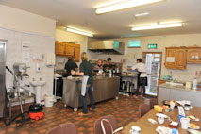

Cost of a dinner per person is €4.50

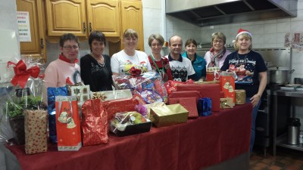
Dinner & dessert per person is €5.00

Meals on Wheels operates:

Monday, Wednesday and Friday.

For further information please contact us:

025-32962

